

**DEPT. Of Computer Science Engineering**

**SRM IST, Kattankulathur – 603 203**

**Sub Code & Name: 18CSS201J - ANALOG AND DIGITAL ELECTRONICS**

|  |  |
| --- | --- |
| **Experiment No** | 04 |
| **Title of Experiment** | Design and implementation of transistor as a switch |
| **Name of the candidate** |  |
| **Register Number** |  |
| **Date of Experiment** |  |

**Mark Split Up**

|  |  |  |  |
| --- | --- | --- | --- |
| **S.No** | **Description** | **Maximum Mark** | **Mark Obtained** |
| 1 | Oral Viva | 5 |  |
| 2 | Execution | 10 |  |
| 3 | Model Calculation / Result Analysis | 5 |  |
| **Total** | | **20** |  |

**Staff Signature with date**

**Aim**

1. To observe the action of a Transistor as an electronic switch.

2. To measure the voltage across the transistor when it is ON and when it is OFF.**Apparatus Required:**

|  |  |  |  |  |
| --- | --- | --- | --- | --- |
| S.No | Apparatus | Type | Range | Quantity |
| 1 | Transistor | Q1 100 A/A |  | 1 |
| 2 | Resistor |  | 1 kΩ,10kΩ | 1 each |
| 3 | DC power source |  | 1.5 V, 12 V | 1 each |
| 4 | Switch | SPST |  | 1 |
| 5 | Probes | Voltage, current |  | 1 each |
| 6 | LED |  |  | 1 |
| 7 | Ground connection |  |  | 1 |
| 8 | Connecting wires |  |  | As required |

**Software Required:**

<https://www.multisim.com/>

**Theory**

The computers of today do not process numbers in the base 10 (i.e., 0, 1, 2, 3, ...,9). Computers instead use binary logic of base 2 (0 and 1) to perform their functions. One fundamental circuit is the transistor switch, also known as an inverter. Here, a transistor connected in a common-emitter fashion inverts a signal. That is, if a high-input signal is applied, a low-output signal is created. If a low-input signal is applied, then a high output signal is created.

In a transistor switch circuit, a voltage level applied to the base terminal will control the potential at the collector. In this fashion, the transistor can be used to turn on or off circuitry connected to the collector. This common-emitter circuit is being switched from cutoff to saturation. In this experiment, a transistor will be connected to demonstrate this switching ability.

**Procedure:**

1. Log in Multisim Live Online Circuit Simulator.
2. Click create circuit button.
3. Change the untitled circuit as Transistor as a switch.
4. Click search for component and type components. Select it and drag to the Schematic window
5. Click search for transistor and NPN. Select it and drag to the Schematic window. Follow this step to select the entire apparatus given in table to complete the circuit.
6. Click schematic connector and select junction drag to the Schematic window and left click at the point and drag to the other point to make the wire connection. Complete the connection according to the diagram.
7. Click analysis and annotation and select voltage probe and drag to the schematic window and place at the input source and left click. Another current probe place at the top side of the collector of transistor and left click.
8. Click the value of the components in circuit and enter the value in the circuit document.
9. Save the file by clicking the file navigation menu at the left top and save with a file name.
10. Click grapher. Enter end time as 1e29 s.
11. Run the simulation by clicking the run simulation. Switch on and off SPST switch at regular intervals.
12. Observe the input and output wave form and note down the values during ON and OFF condition of the transistor.

Circuit Diagram:

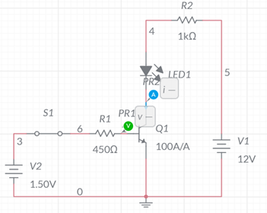

Transistor as a switch

Method for component selection

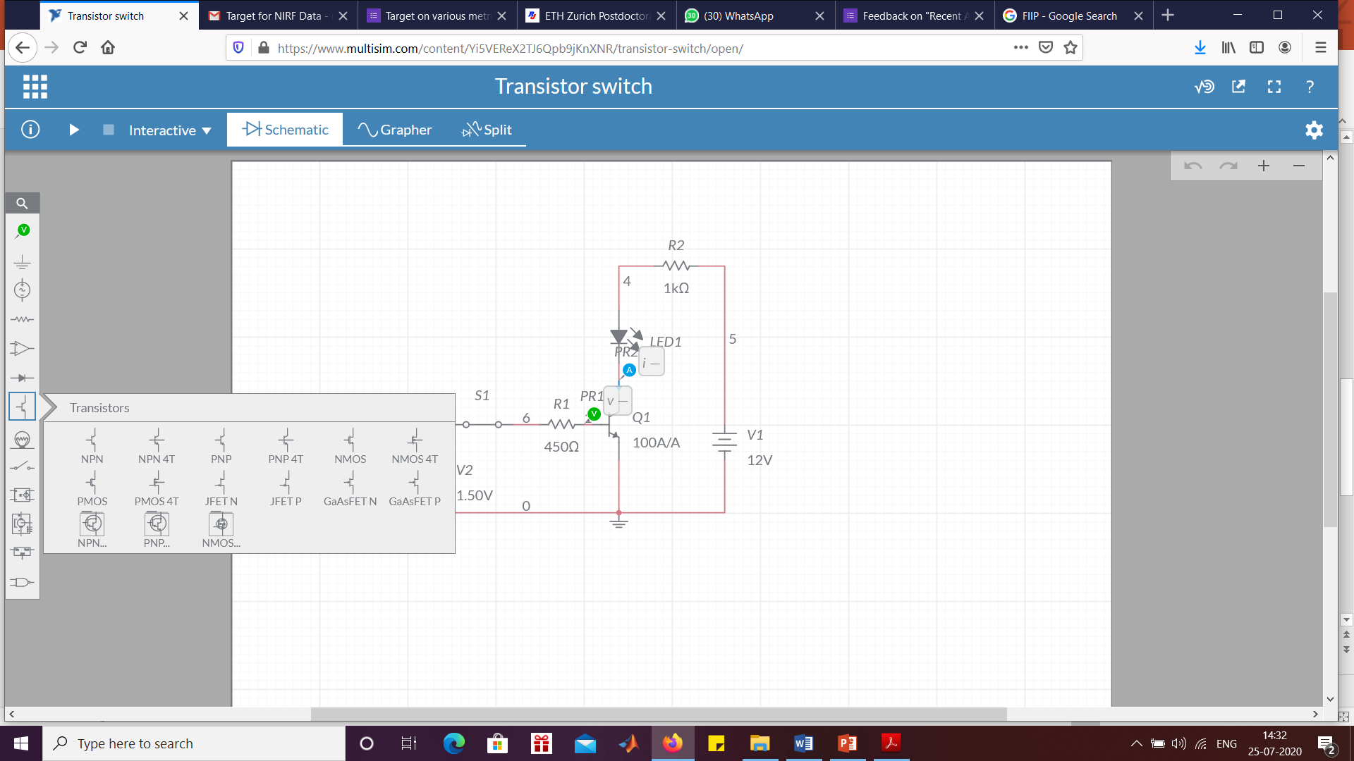

* Click search for transistor and NPN. Select it and drag to the Schematic window. Follow this step to make entire circuit as shown in table

Method for observing the grapher to provide time details

Enter time value here

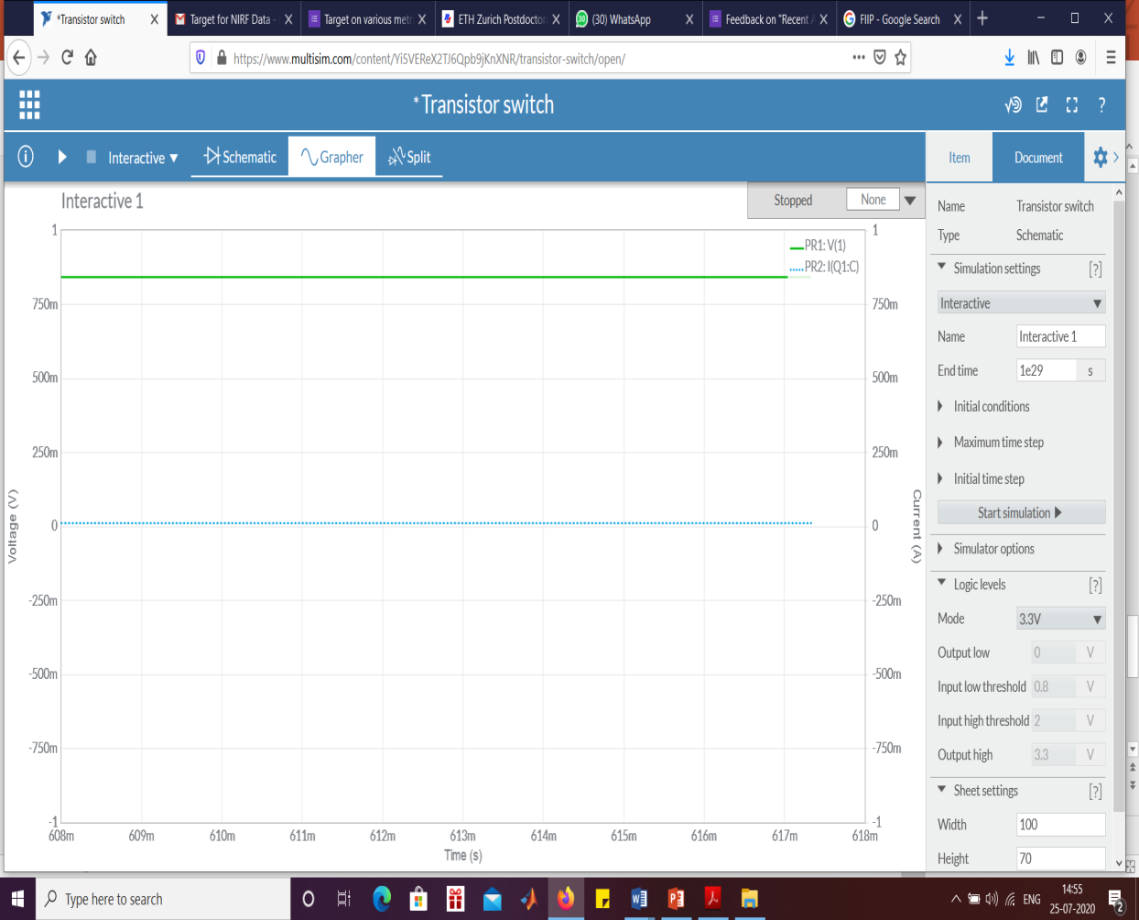

Method to run the simulation

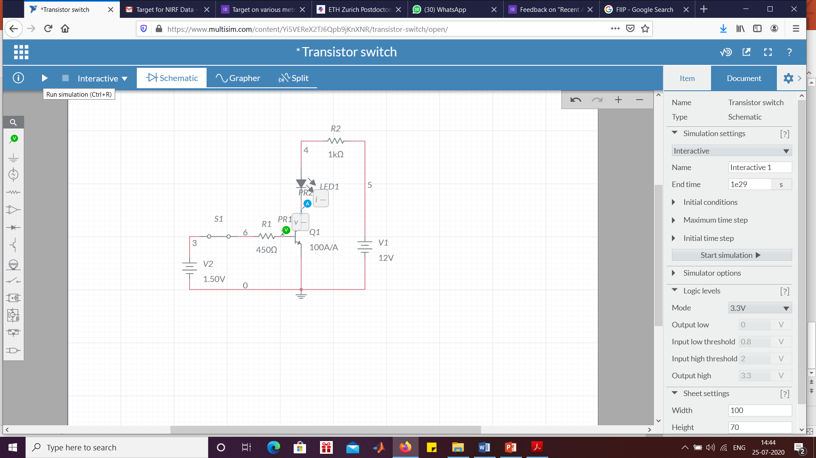

Switch ON and OFF condition

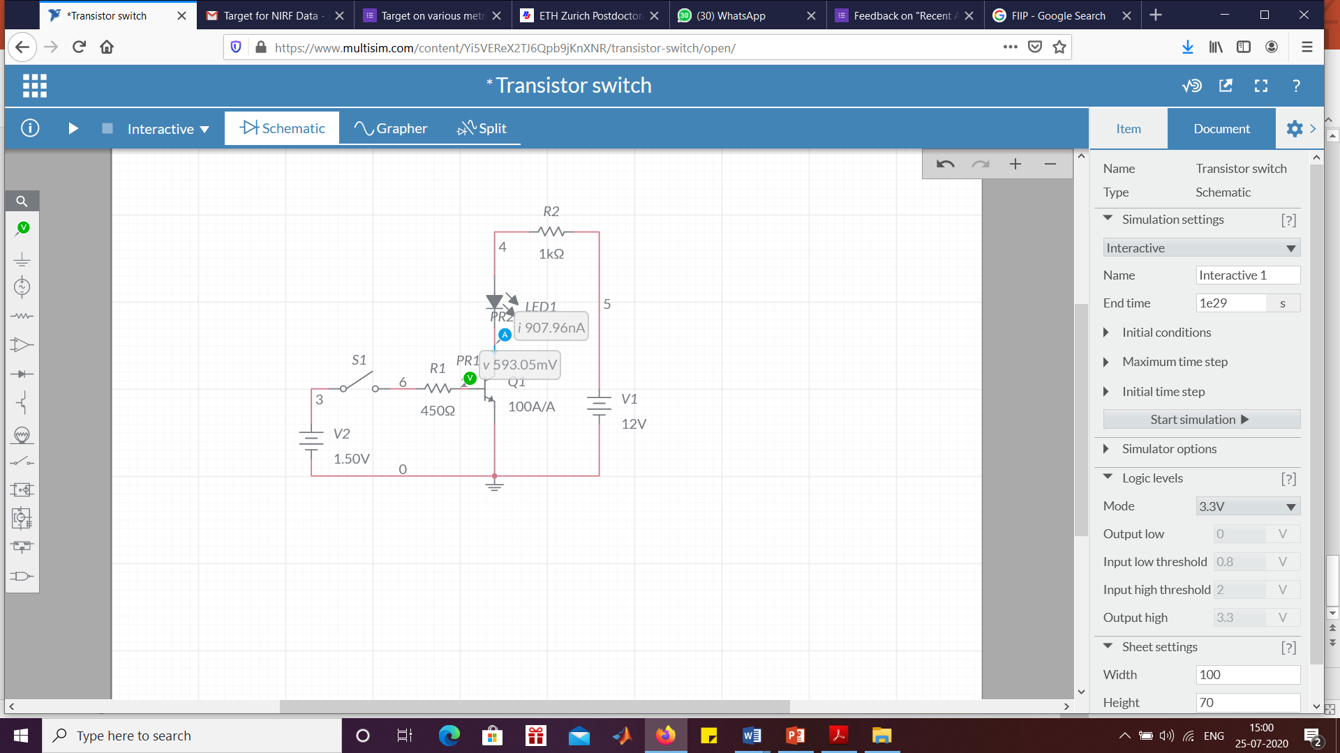 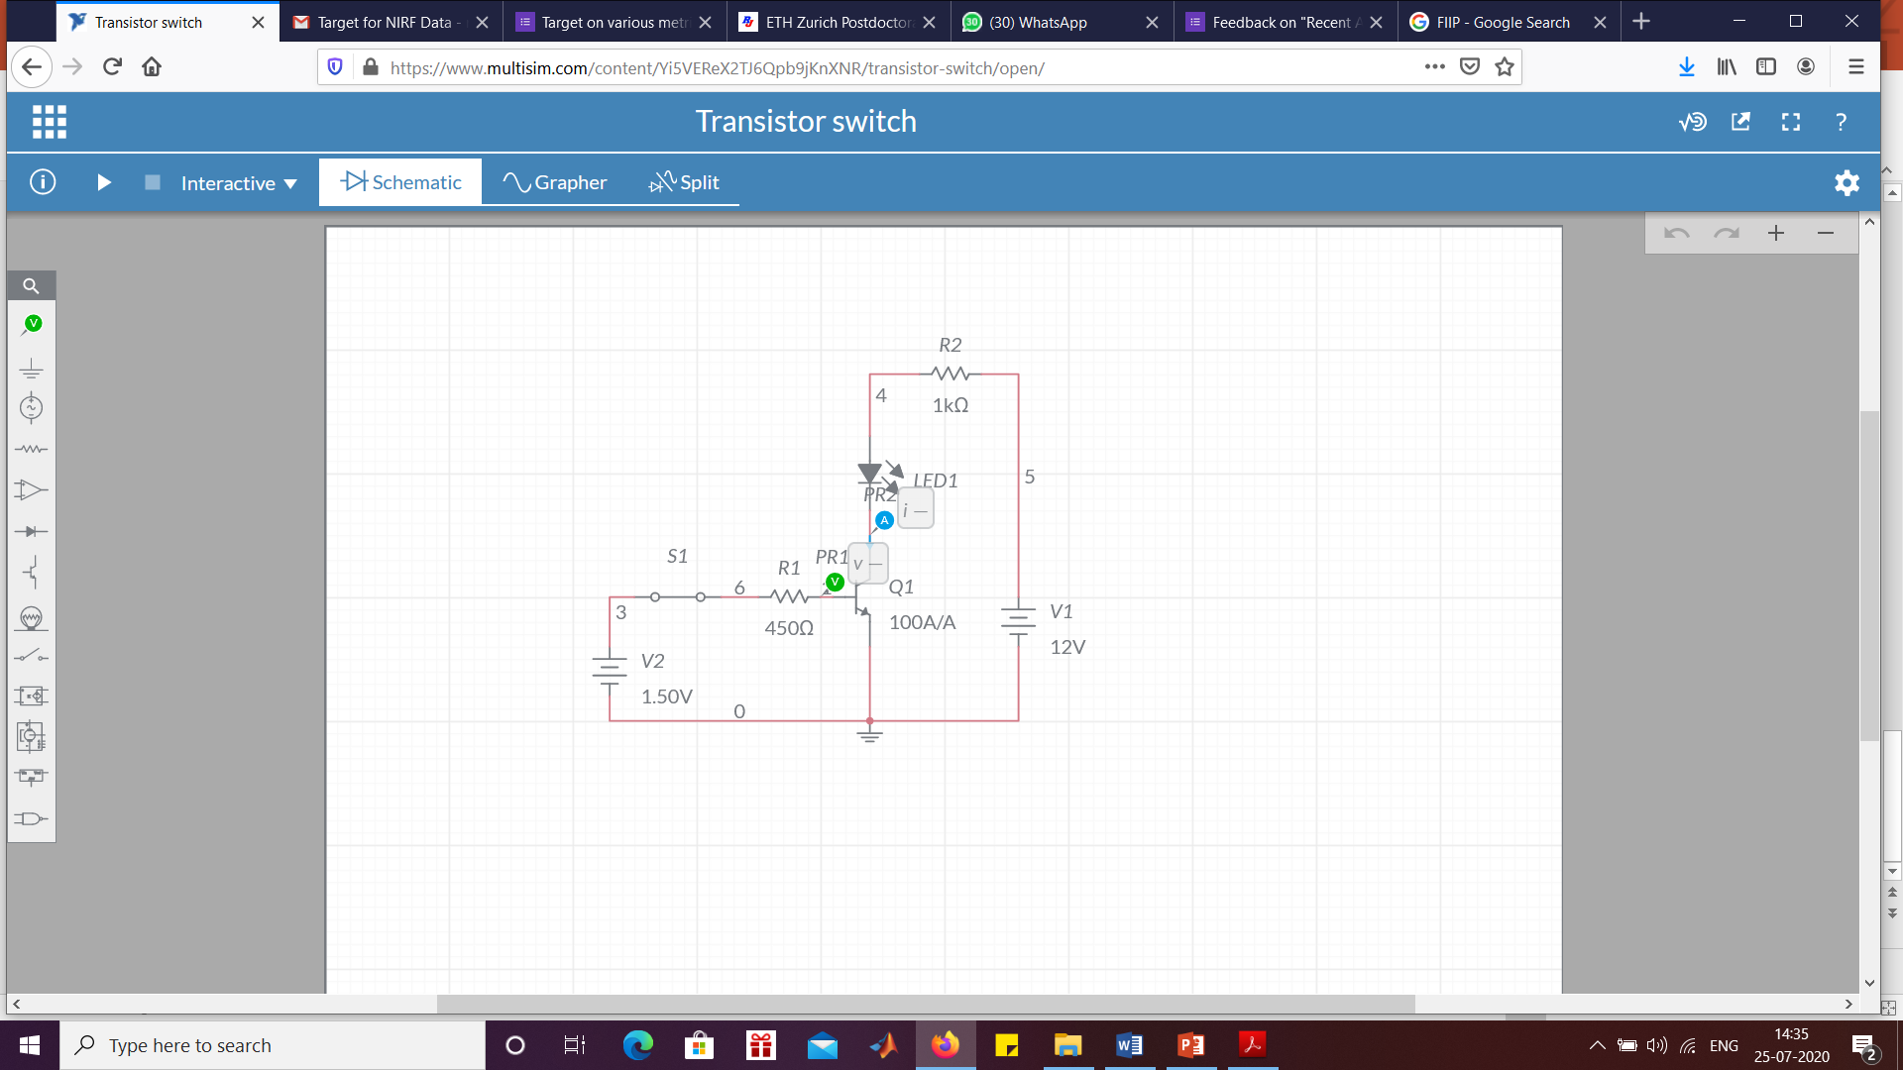

Method to get proper scales for the waveforms

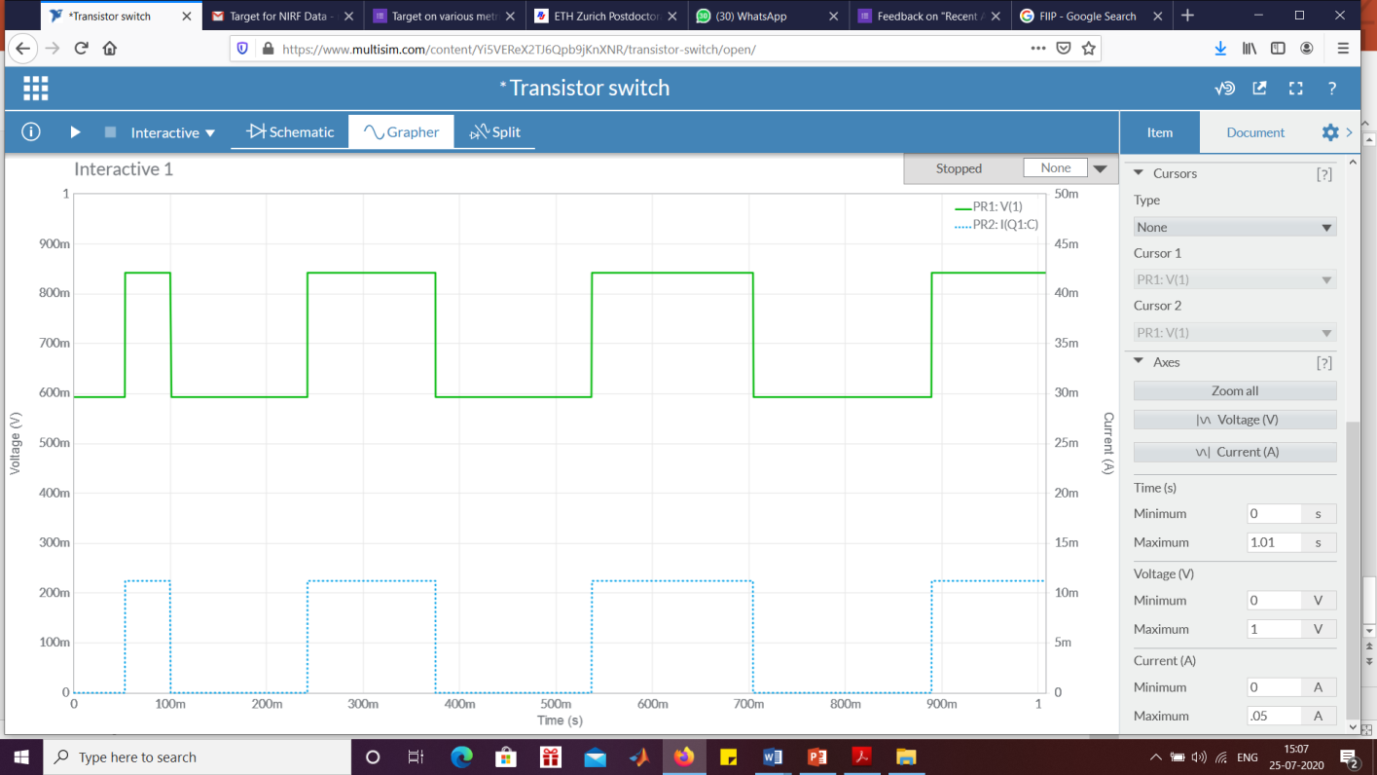

Expected output waveforms

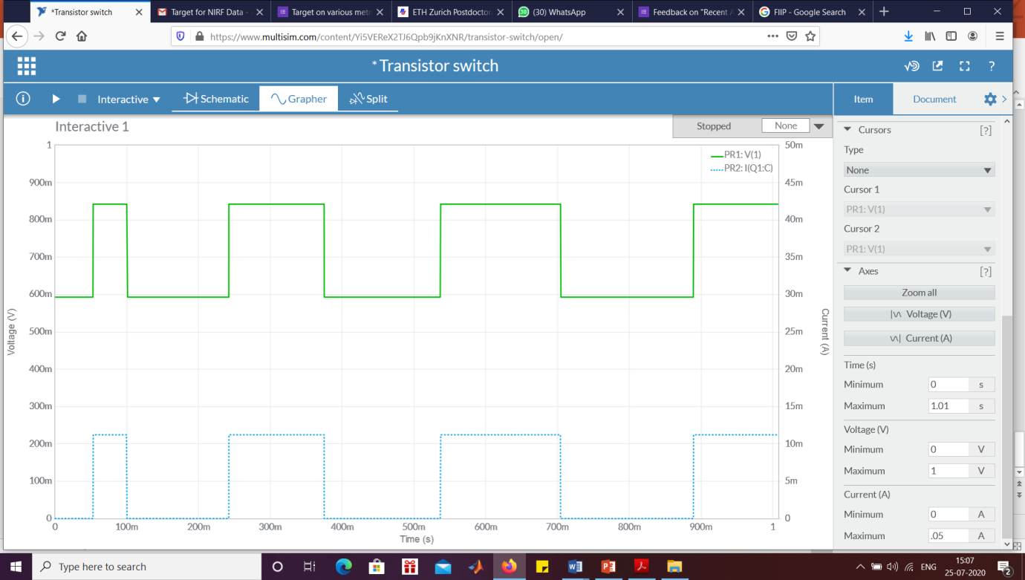

Tabulation

|  |  |  |
| --- | --- | --- |
| Switch | Status of probe | Voltage value |
| ON |  |  |
| OFF |  |  |

**RESULT**

Thus, the transistor as a switch was designed and the output voltage and status of the

Probe was tabulated.